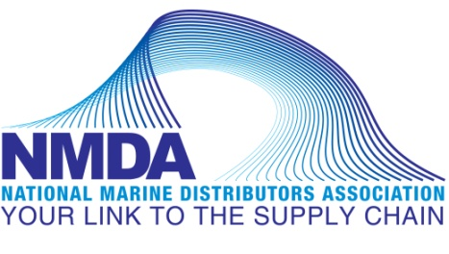
Distributor Show Dates
Information current as of February 2019

2019 Show Dates

2019 Show Dates

2019 Kimpex Marine & Moto/ATV
August 20th-21st, 2019
Contact: Samuel Bernier
Hilton Casino Lac-Leamy
Gatineau, Qc, Canada

Northern Wholesale Marine Show
September 16-19th, 2019
Contact: Kristine Otte
Treasure Island Resort & Casino
Red Wing, MN

CC Marine Distributors
Trade Show
October 21 & 22, 2019
Contact: Rick Chang or Bruce Hamer
Hilton Toronto/Markham Suites Conference Centre
Markham, ON Canada

Vita-Plate Distributor
October 23, 2019
Contact: Marisa Kobus
Location TBD

Keller Marine and R.V. Show
Keller Marine Dealer Show
October 29 & 30, 2019
Contact: Lori Morrow
Lancaster County Convention Center
Lancaster, PA

Paxton Company
Mid-Atlantic Marine Expo
November 7, 2019
Contact: Lindsay McElheney
Virginia Beach Convention Center
Virginia Beach, VA

MESCO (MESCO & Seacoast)
56th Annual Dealer Show
November 13 & 14, 2019
Contact: Don Zabransky or Don Kirkland III
Waterfront Conference Center at
Harrah’s Resort Casino
Atlantic City, NJ

Brunswick P&A (Kellogg Marine / Land N Sea)
Kellogg Marine/Land ‘N’Sea Marine Dealer Trade Show
November 21 & 22, 2019
Contact: Debbie Bellantoni
Mohegan Sun
Uncasville, CT

2020 Show Dates

Northern Wholesale Marine Show
September 20-22nd, 2020
Contact: Kristine Otte
Treasure Island Resort & Casino
Red Wing, MN

MESCO (MESCO & Seacoast)
57th Annual Dealer Show
November 11 & 12, 2020
Contact: Don Zabransky or Don Kirkland III
Waterfront Conference Center at
Harrah’s Resort Casino
Atlantic City, NJ

2021 Show Dates

Northern Wholesale Marine Show
September 20-23rd, 2021
Contact: Kristine Otte
Treasure Island Resort & Casino
Red Wing, MN

MESCO (MESCO & Seacoast)
58th Annual Dealer Show
November 10 & 11, 2021
Contact: Don Zabransky or Don Kirkland III
Waterfront Conference Center at
Harrah’s Resort Casino
Atlantic City, NJ

